Bo Lin

**ECE 479/579 Digital Control Systems**

Project #1

**2.1** **Design feedback with lead compensation for the open-loop system**



The rise time should be 1 sec or less and the overshoot should be less than 10%.



(a) The closed-loop transfer function of the system is



The Root Locus graph shows below.

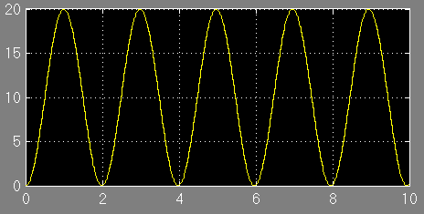

When ,roots of characteristic equation are imaginary, step response is purely sinusoidal with frequency .

The Bode plot shows below.





(b) Adding the lead compensator

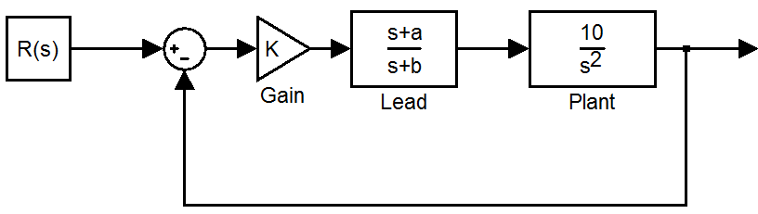





Since in step and ramp input, the type 2 system has 0 for steady-state error, for the unit parabolic input , the steady-state error is 0.1.







Design a phase margin of 75 degree.



The compensator will shift the magnitude upwards by



at  .

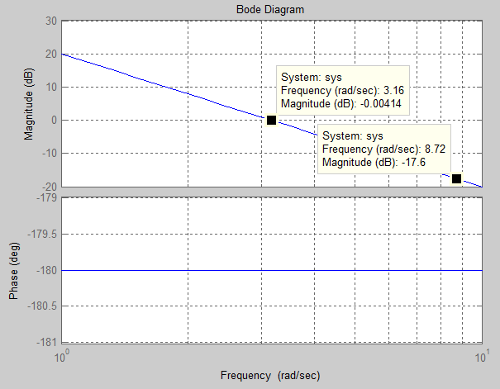







The Simulink Model:

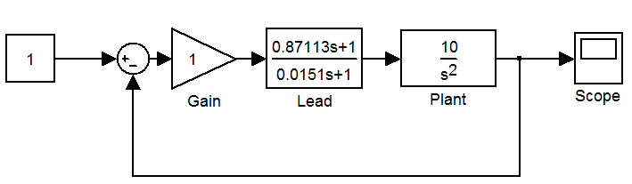

The result:

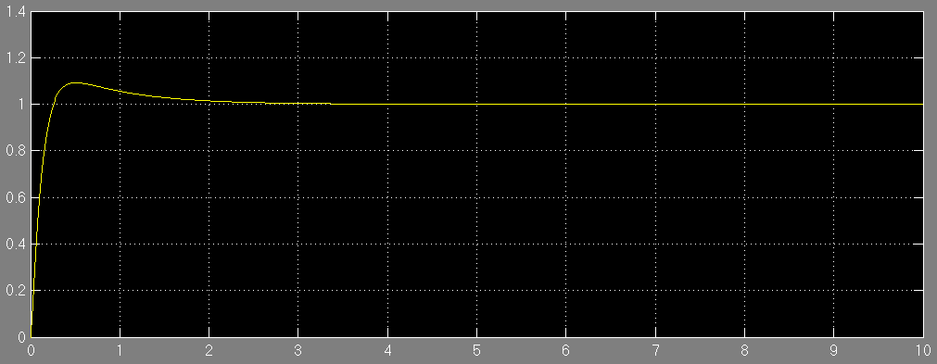



**2.8 Consider a** **pendulum with control torque  and** **disturbance torque  whose differential equation is**

**,**

**Assume there is a potentiometer at the pin that measures the output angle  , that is,  .**

**(a) Design a lead compensation using frequency response that provides for a PM>50 and a bandwidth, rad/sec.**



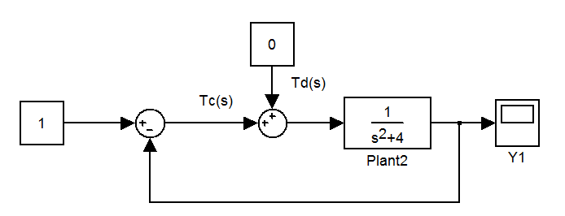

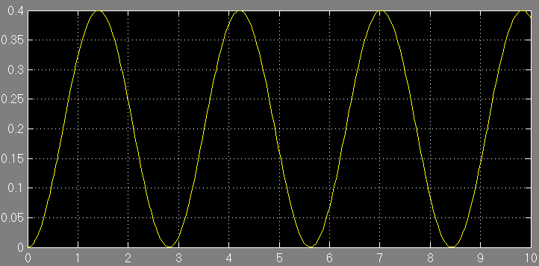





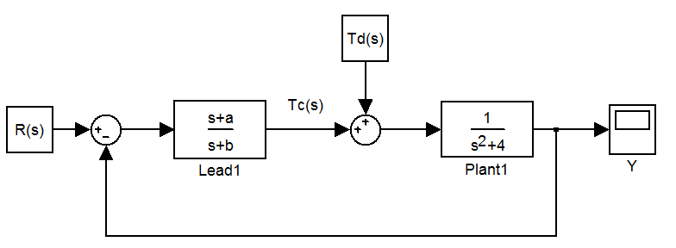

For phase margin >50, 

If set PM to 60 degree.

  .

The compensator will shift the magnitude upwards by



at  .

The cross over frequency is around 2.2rad/s.

By pushing ahead 8.78dB, can get 







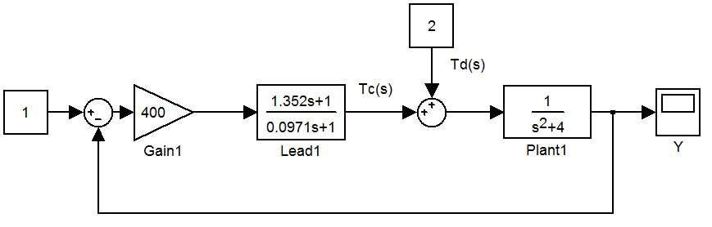

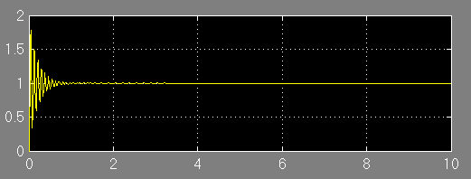

The steady-state error is as designed 1%.

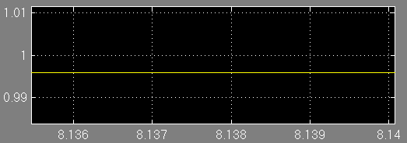



The phase margin is too small.



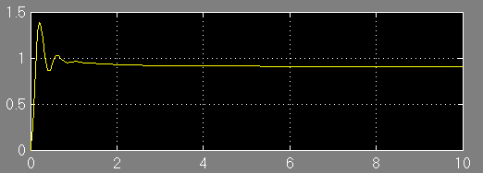



Phase Margin increases to 51 degree.

If retune tau to increase PM,





If the compensator does not have any poles at the origin, the gain K just shifts the plant’s magnitude curve by at all frequencies.

So let K=10.

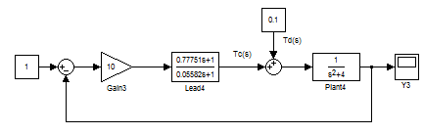

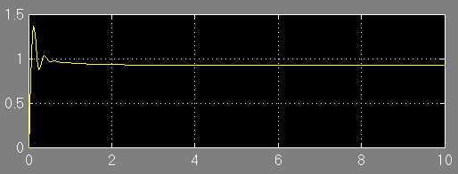



After retuning, the PM>50, the steady-state error is less.

**(b) Add an integral term to your controller so that there is no steady-state error in the presence of a constant disturbance,  , and modify the compensation so that the specifications are still met.**

The system after adding an integral term

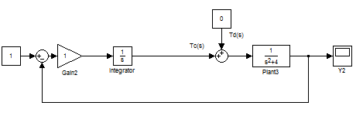



After adding an integral term, the phase will be -270 degree.

Suppose the safety factor is 10 degree initially.



According to

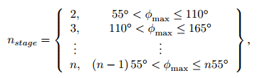

So at least apply three lead compensators to the system.

Suppose each compensator has a phase shift of 50 degree.





$$Φ=50$$

$α=0.13247$

$$10\log_{10}{\frac{1}{α}}=21.161dB$$

Initially choose  according to (a) at 2.83 rad/s.

$$zc=2.83\sqrt{0.13247}=1.03$$

$$pc=\frac{1.03}{0.13247}=7.7755$$

$$G_{lead}=\frac{(\frac{s}{1.03}+1)}{(\frac{s}{7.7755}+1)}=\frac{0.97087s+1}{0.12861s+1}$$

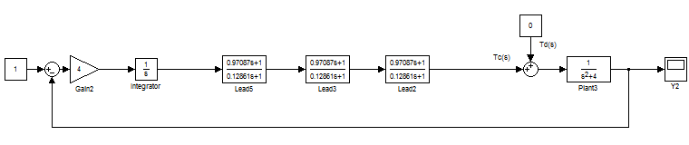

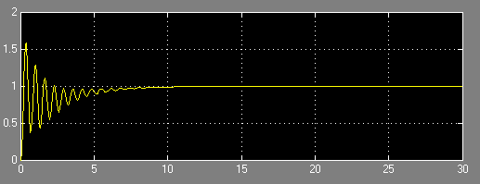

The bode plot (with Kc gain 10) shows that the phase margin still not satisfy the requirement.



**Solution 1**

Find the frequency that satisfy PM=50, where , in Magnitude plot, the Magnitude is around 17.9dB.





With the new gain, the system satisfies PM around 50.

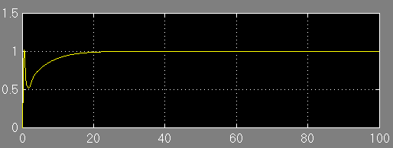

But since the K is very small, the response time is very long.

**Solution 2**

Change the  to the desired PM frequency according to solution 1 bode plot , remain K and  the same as before.



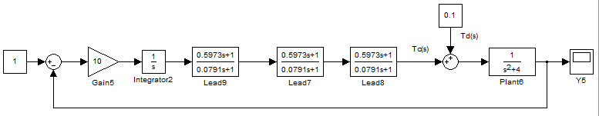

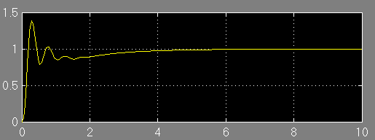



This time, both the model and bode plot performance are better, and due to the additional integral term, the system has no steady state error.

For further improvement, I can increase the K and get quicker rising, in that case, the  should be retuned again.

Main Reference

“Phase Lead Compensator Design Using Bode Plots”, Guy Beale, Electrical and Computer Engineering Department, George Mason University, Fairfax, Virginia.